# DEPARTMENT OF COMPUTER SCIENCE

**MSc(CS) PART-II SEMESTER III**

**Course Code:** PSCSP3042

Practical Journal

in

**Data Science (****Big Data Analytics)**

Submitted by

**SEAT NUMBER –**

**Roll No –**

for the academic year

**2023-2024**

**Index**

|  |  |  |
| --- | --- | --- |
| **Sr. No.** | **Practical** | **Date** |
| 1 | Installing and setting environment variables for Working with Apache Hadoop. |  |
| 2 | Implementing Map-Reduce Program for Word Count problem. |  |
| 3 | Download and install Spark. Create Graphical data and access the graphical data using Spark. |  |
| 4 | Write a Spark code for the given application and handle error and recovery of data. |  |
| 5 | Write a Spark code to Handle the Streaming of data. |  |
| 6 | Install Hive and use Hive Create and store structured databases. |  |
| 7 | Install HBase and use the HBase Data model Store and retrieve data. |  |
| 8 | Write a Pig Script for solving counting problems. |  |

# Practical No.1

## Installing and setting environment variables for Working with Apache Hadoop.

The **Apache Hadoop software library** is a framework that allows for the distributed processing of large data sets across clusters of computers using simple programming models. It is designed to scale up from single servers to thousands of machines, each offering local computation and storage. Rather than rely on hardware to deliver high-availability, the library itself is designed to detect and handle failures at the application layer, so delivering a highly-available service on top of a cluster of computers, each of which may be prone to failures.

# Installing Java

In Ubuntu, open the terminal and enter the following command:

$ sudo apt install default-jdk default-jre -y

Verify the installation via

$ java -version

In terminal, install openssh client and server

$ apt install openssh-server openssh-client -y

Generate public and private key pairs.

$ ssh-keygen -t rsa

Add the generated public key from id_rsa.pub to authorized_keys.

$ sudo cat ~/.ssh/id_rsa.pub >> ~/.ssh/authorized_keys

Change the permissions of the authorized_keys file.

$ sudo chmod 640 ~/.ssh/authorized_keys

Verify if the password-less SSH is functional.

$ ssh localhost

**Download the latest stable version of Hadoop. To get the latest version, go to Apache Hadoop** [**official download**](https://downloads.apache.org/hadoop/common/stable/) **page.**

$ wget [https://downloads.apache.org/hadoop/common/hadoop-3.3.1/hadoop-](https://downloads.apache.org/hadoop/common/hadoop-3.3.1/hadoop-3.3.1.tar.gz) [3.3.1.tar.gz](https://downloads.apache.org/hadoop/common/hadoop-3.3.1/hadoop-3.3.1.tar.gz)

**Extract the downloaded file.**

$ tar -xvzf hadoop-3.3.1.tar.gz

**Move the extracted directory to the /usr/local/ directory.**

$ sudo mv hadoop-3.3.1 /usr/local/hadoop

**Create directory to store system logs.**

$ sudo mkdir /usr/local/hadoop/logs

**Change the ownership of the hadoop directory.**

$ sudo chown -R hadoop:hadoop /usr/local/Hadoop

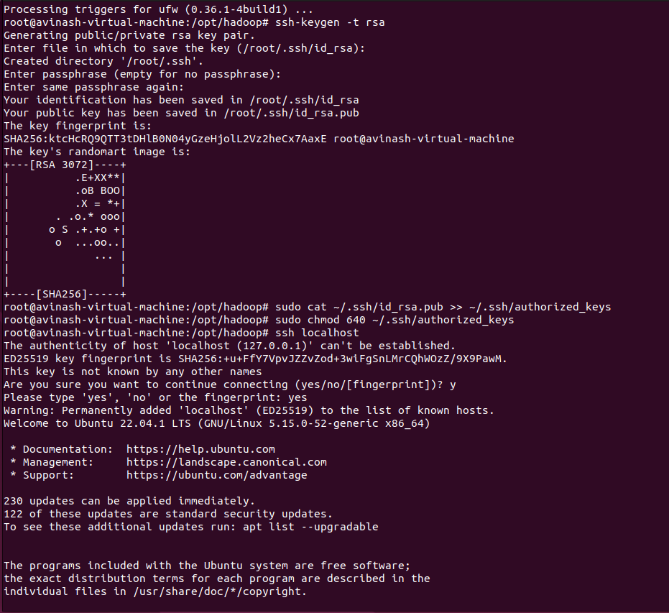

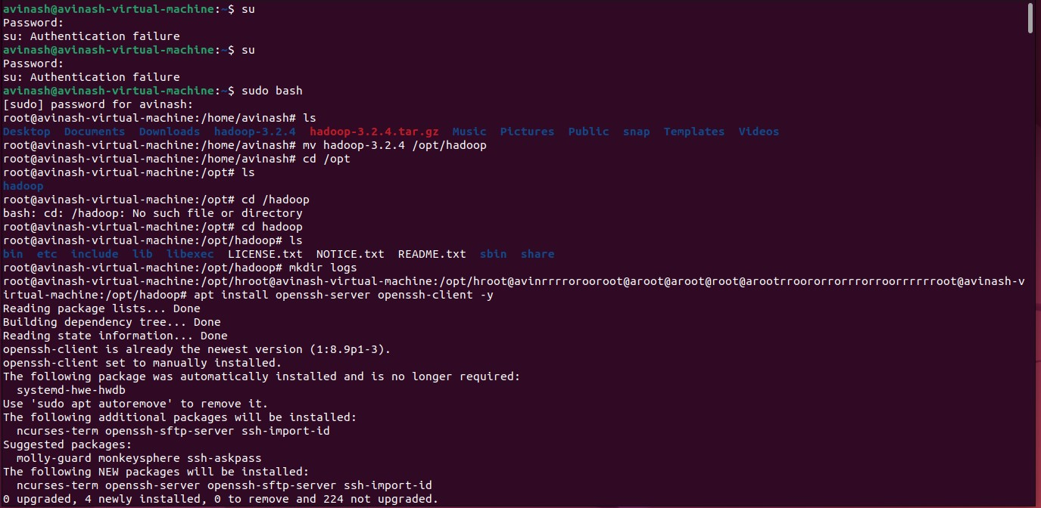

$ sudo nano ~/.bashrc

Add the following lines to the file. Save and close the file. export HADOOP_HOME=/usr/local/hadoop export HADOOP_INSTALL=$HADOOP_HOME

export HADOOP_MAPRED_HOME=$HADOOP_HOME

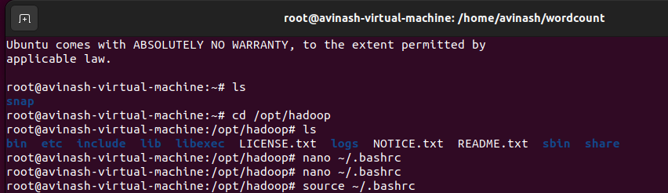

export HADOOP_COMMON_HOME=$HADOOP_HOME export HADOOP_HDFS_HOME=$HADOOP_HOME

export YARN_HOME=$HADOOP_HOME

export HADOOP_COMMON_LIB_NATIVE_DIR=$HADOOP_HOME/lib/native export PATH=$PATH:$HADOOP_HOME/sbin:$HADOOP_HOME/bin

export HADOOP_OPTS="-Djava.library.path=$HADOOP_HOME/lib/native"

* Activate the environment variables.

**The source command** is used in order to evaluate the file passed as an argument in the context of the current execution.

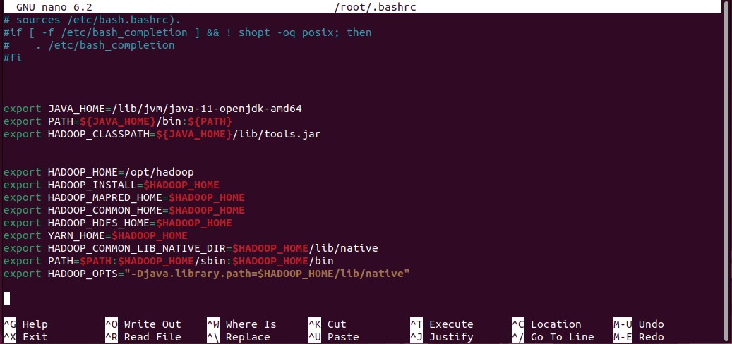$ source ~/.bashrc

**Configure Java Environment Variables**

* Verify the Hadoop version.

$ hadoop version

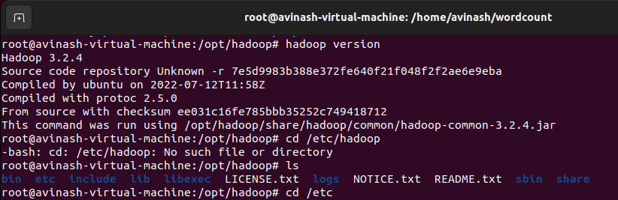

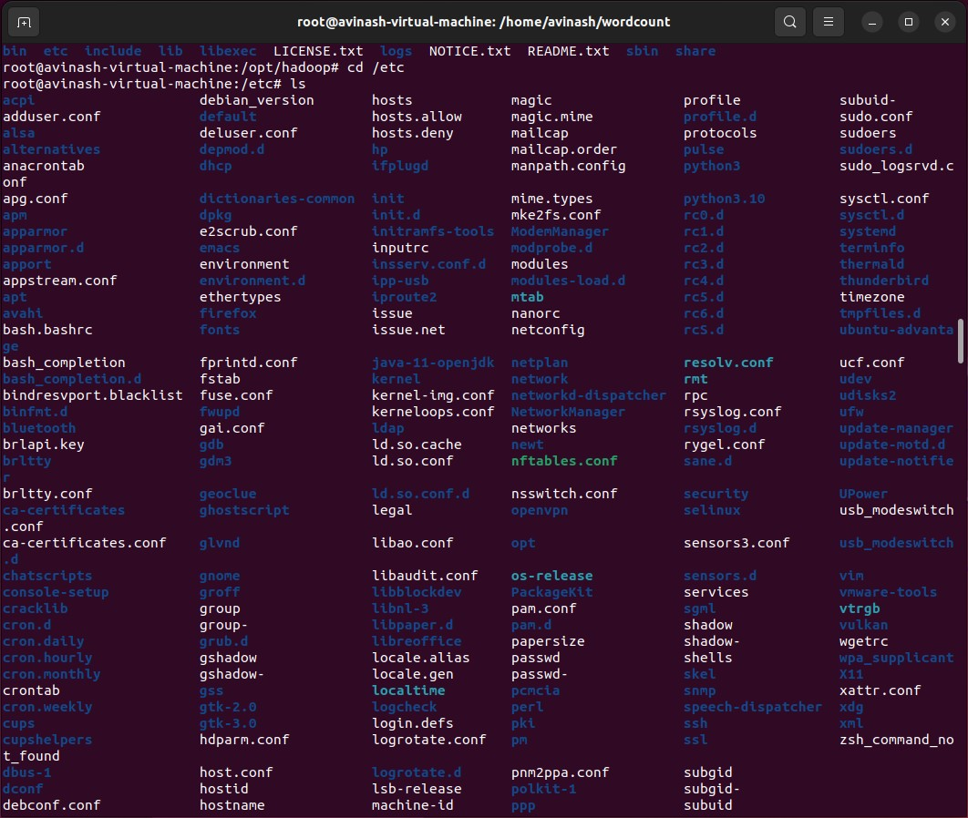

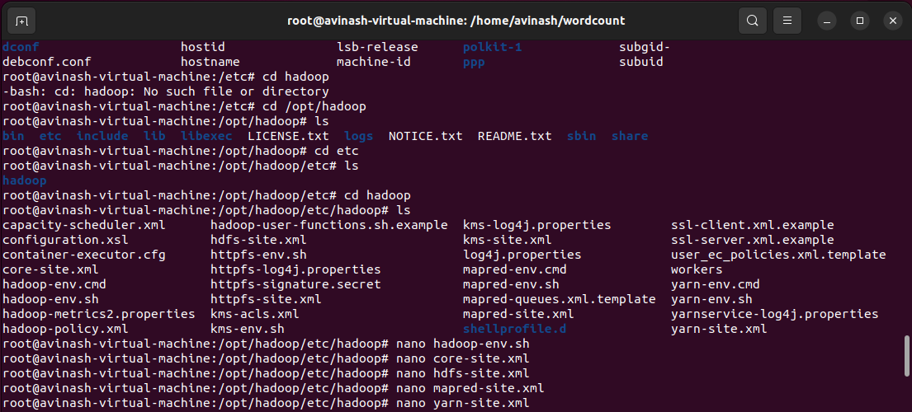

### Edit the hadoop-env.sh file.

**To create and open a new file. $nano new_filename**

$ sudo nano $HADOOP_HOME/etc/hadoop/hadoop-env.sh

* 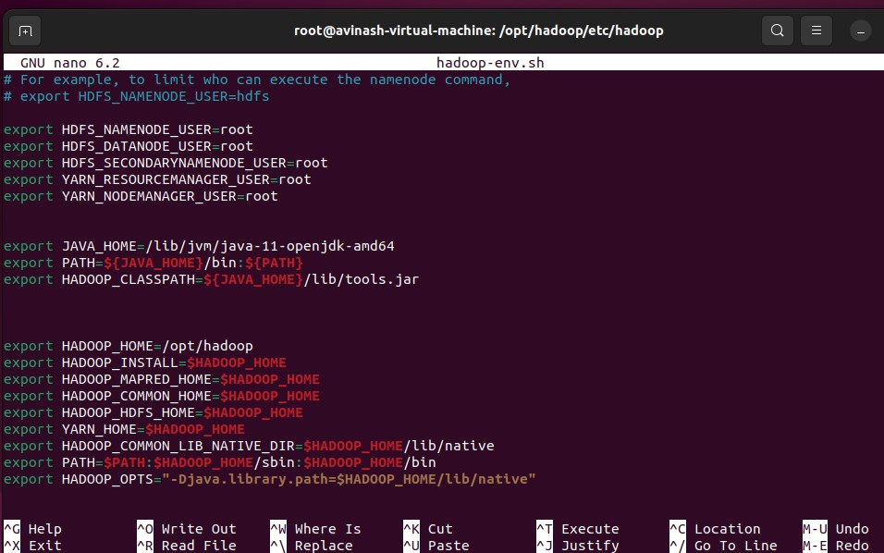Add the following lines to the file. Then, close and save the file. export JAVA_HOME=/usr/lib/jvm/java-11-openjdk-amd64 export HADOOP_CLASSPATH+=" $HADOOP_HOME/lib/*.jar"
  + **Edit the core-site.xml configuration file** to specify the URL for your NameNode.

**To create and open a new file** $nano new_filename

$ sudo nano $HADOOP_HOME/etc/hadoop/core-site.xml

* Add the following lines. Save and close the file.

<configuration>

<property>

<name>fs.default.name</name>

<value>hdfs://0.0.0.0:9000</value>

<description>The default file system URI</description>

</property>

</configuration>

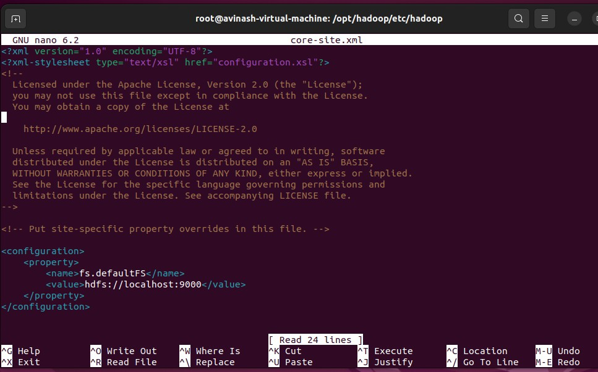

* **Edit hdfs-site.xml configuration file** to define the location for storing node metadata, fs-image file.

### To create and open a new file.

$nano new_filename

$ sudo nano $HADOOP_HOME/etc/hadoop/hdfs-site.xml

* Add the following lines. Close and save the file.

<configuration>

<property>

<name>dfs.replication</name>

<value>1</value>

</property>

<property>

<name>dfs.name.dir</name>

<value>file:///home/hadoop/hdfs/namenode</value>

</property>

<property>

<name>dfs.data.dir</name>

<value>file:///home/hadoop/hdfs/datanode</value>

</property>

</configuration>

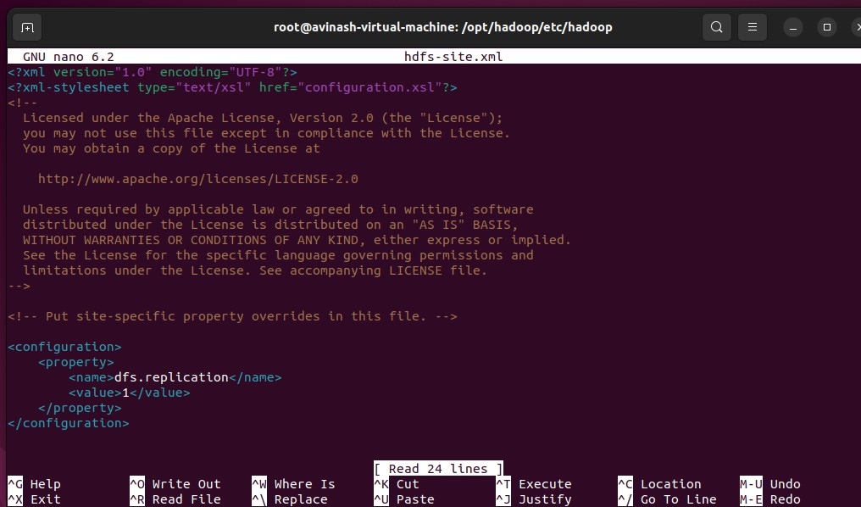

* **Edit mapred-site.xml configuration file** to define MapReduce values.

**To create and open a new file**. $nano new_filename

$ sudo nano $HADOOP_HOME/etc/hadoop/mapred-site.xml

* Add the following lines. Save and close the file.

<configuration>

<property>

<name>mapreduce.framework.name</name>

<value>yarn</value>

</property>

</configuration>

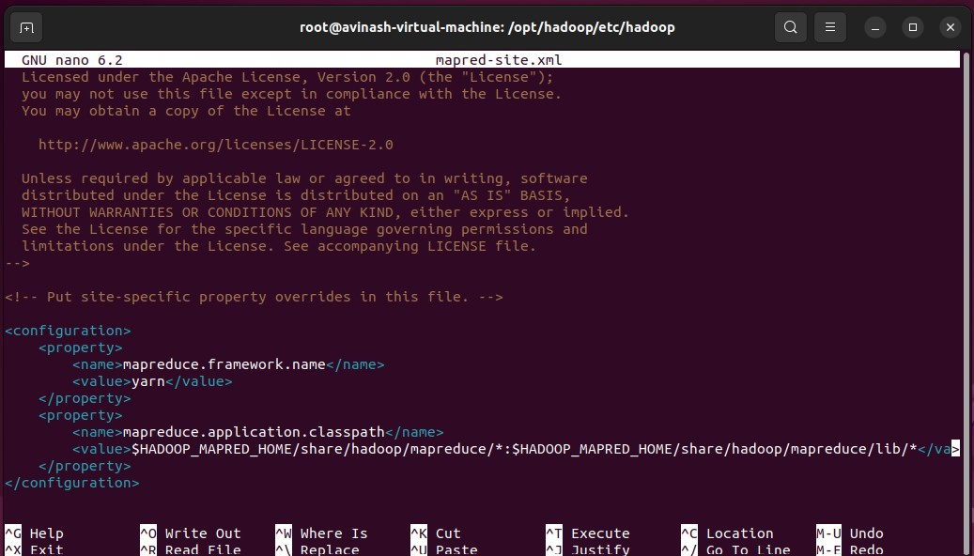

* **Edit the yarn-site.xml configuration file** and define YARN-related settings.

**To create and open a new file**. $nano new_filename

$ sudo nano $HADOOP_HOME/etc/hadoop/yarn-site.xml

* Add the following lines. Save and close the file.

<configuration>

<property>

<name>yarn.nodemanager.aux-services</name>

<value>mapreduce_shuffle</value>

</property>

</configuration>

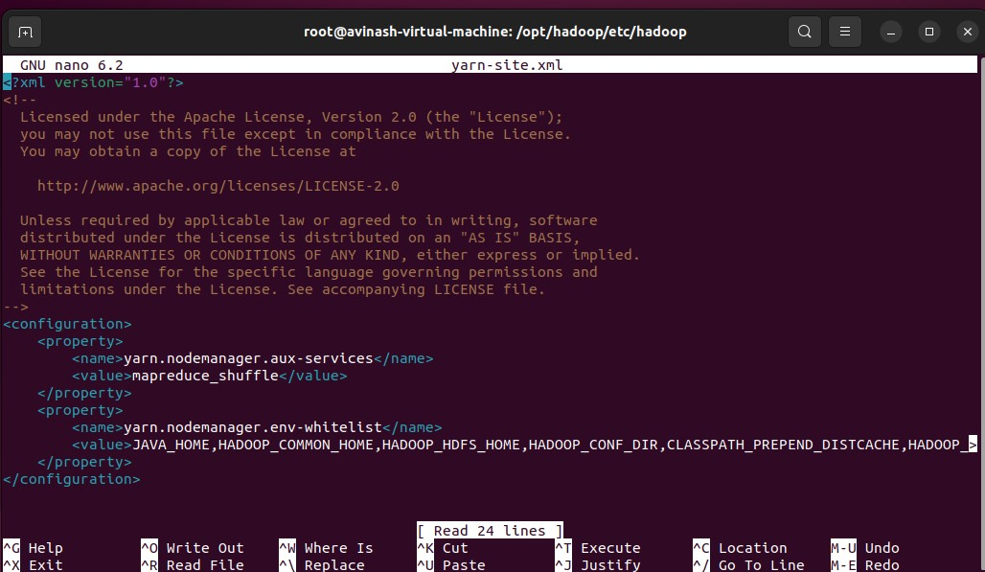

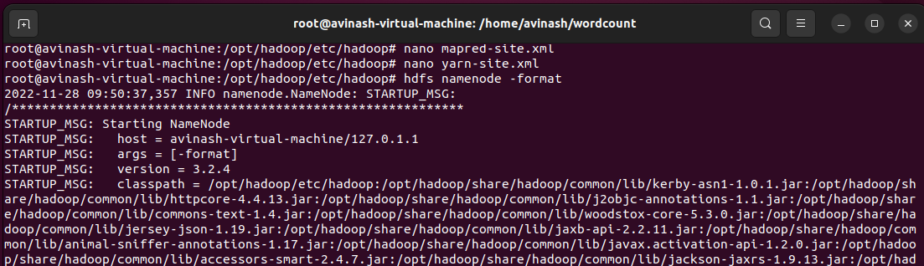

### Log in with hadoop user.

The **sudo command** lets us use our account and password to execute system commands with root privileges, whereas the **su command** allows us to switch to a different user and execute one or more commands in the shell without logging out from our current session.

both sudo and su allows command execution as any user.

$ sudo su – Hadoop

### Validate the Hadoop configuration and format the HDFS NameNode.

**The NameNode** is the centerpiece of an HDFS file system. It keeps the directory tree of all files in the file system, and tracks where across the cluster the file data is kept.

$ hdfs namenode -format

### Step 7:- Start the Apache Hadoop Cluster

* Start the NameNode and DataNode.
  + **NameNod**e is the centerpiece of HDFS. **NameNode** is also known as the Master
  + **NameNode** only stores the metadata of HDFS – the directory tree of all files in the file system, and tracks the files across the cluster.
  + **DataNode** is responsible for storing the actual data in HDFS. **DataNode** is also known as the Slave

**NameNode and DataNode** are in constant communication.

* + When a **DataNode** starts up it announce itself to the NameNode along with the list of blocks it is responsible for.
  + **DataNode** is usually configured with a lot of hard disk space. Because the actual data is stored in the DataNode.

### start-all.sh & stop-all.sh

Used to start and stop Hadoop daemons all at once. Issuing it on the master machine will start/stop the daemons on all the nodes of a cluster

$ start-dfs.sh

* Start the YARN resource and node managers.

### start-dfs.sh, stop-dfs.sh and start-yarn.sh, stop-yarn.sh

Same as above but start/stop HDFS and YARN daemons separately on all the nodes from the master machine.

$ start-yarn.sh

* Verify all the running components.

**JPS** is a type of command that is implemented to check out all the Hadoop daemons like DataNode, NodeManager, NameNode, and ResourceManager that are currently running on the machine.

$ jps

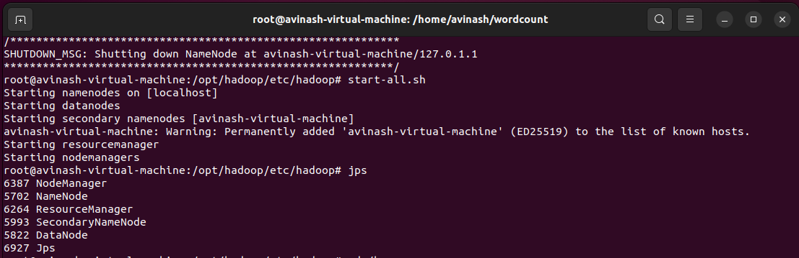

# Practical No.2

## Implementing Map-Reduce Program for Word Count problem.

**MapReduce** is a processing technique and a program model for distributed computing based on java. The MapReduce algorithm contains two important tasks, namely Map and Reduce. Map takes a set of data and converts it into another set of data, where individual elements are broken down into tuples (key/value pairs). **MapReduce** program executes in three stages, namely map stage, shuffle stage, and reduce stage.

**Map stage −** The map or mapper’s job is to process the input data. Generally the input data is in the form of file or directory and is stored in the Hadoop file system (HDFS). The input file is passed to the mapper function line by line.

**Reduce stage −** This stage is the combination of the Shuffle stage and the Reduce stage. The Reducer’s job is to process the data that comes from the mapper. After processing, it produces a new set of output, which will be stored in the HDFS.

### Inputs and Outputs

* + The MapReduce framework operates exclusively on <key, value> pairs, that is, the framework views the input to the job as a set of <key, value> pairs and produces a set of <key, value> pairs as the output of the job, conceivably of different types.
  + The key and value classes have to be serializable by the framework and hence need to implement the [Writable](https://hadoop.apache.org/docs/r1.2.1/api/org/apache/hadoop/io/Writable.html) interface. Additionally, the key classes have to implement the [Writable](https://hadoop.apache.org/docs/r1.2.1/api/org/apache/hadoop/io/WritableComparable.html) [Comparable](https://hadoop.apache.org/docs/r1.2.1/api/org/apache/hadoop/io/WritableComparable.html) interface to facilitate sorting by the framework.

### Input and Output types of a MapReduce job:

* (input) <k1, v1> -> map -> <k2, v2> -> combine -> <k2, v2> -> reduce -> <k3, v3> (output)
* **WordCount** is a simple application that counts the number of occurences of each word in a given input set.
* This works with a local-standalone, pseudo-distributed or fully-distributed Hadoop installation.

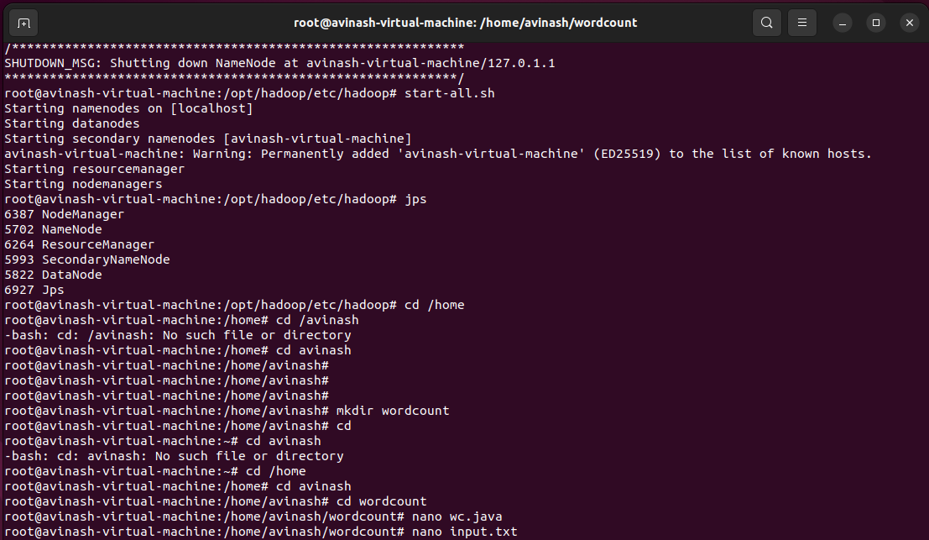

* + Write the MapReduce program

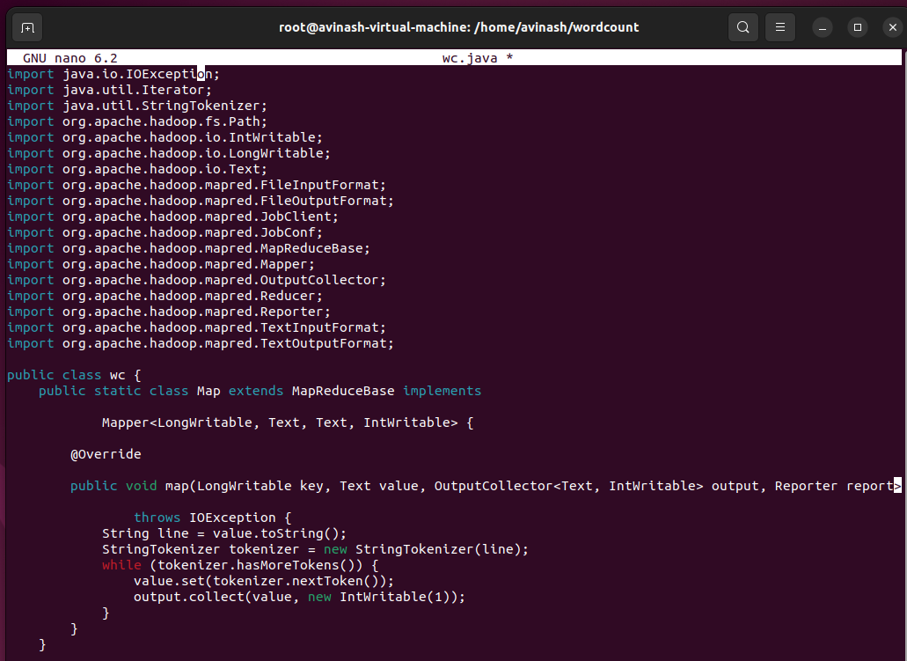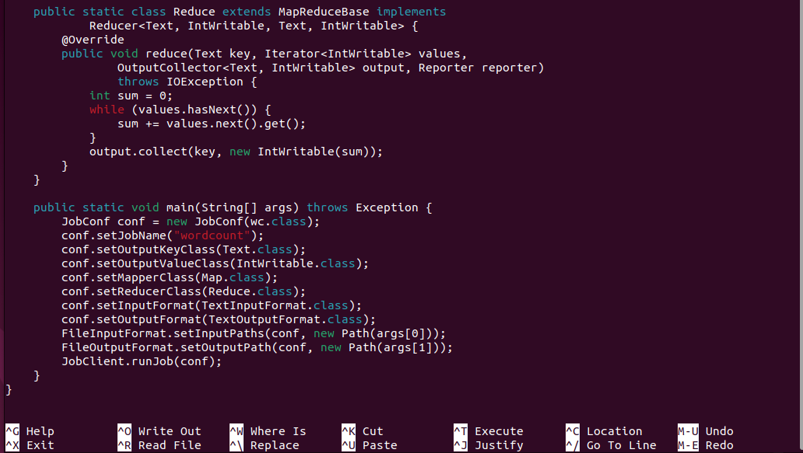

### Assuming that:

* + /usr/joe/wordcount/input - input directory in HDFS
  + /usr/joe/wordcount/output - output directory in HDFS
  + **Create a text file** in your local machine and write some text into it.

**To create and open a new file**. $nano new_filename

$ nano input.txt

* + Create the jar file of this program and name it wc.jar.

**A JAR (Java ARchive)** is platform-independent file format used to aggregate many Java class files

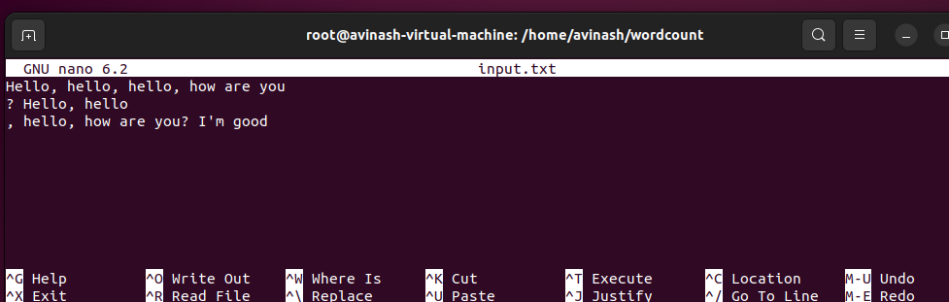

and associated metadata and resources such as text, images, etc, into a single file for distribution.

* + Upload the data.txt file on HDFS in the specific directory.
  + **hdfs dfs -put** - Transfer and store a data file from local system to the Hadoop file system using the put command. Or Upload a file / Folder from the local disk to HDFS.

# hdfs dfs -put /home/avinash/wordcount/input.txt /

* + **List files** with permissions and other details

# hdfs dfs -ls /

# hadoop jar /home/avinash/wordcount/wc.jar wc /input.txt /output

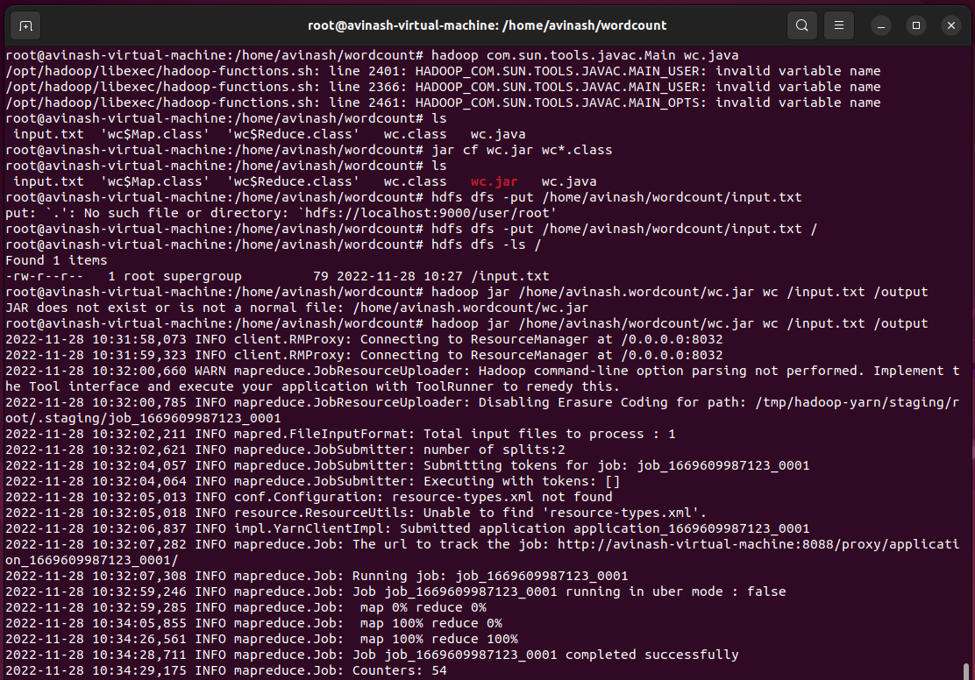

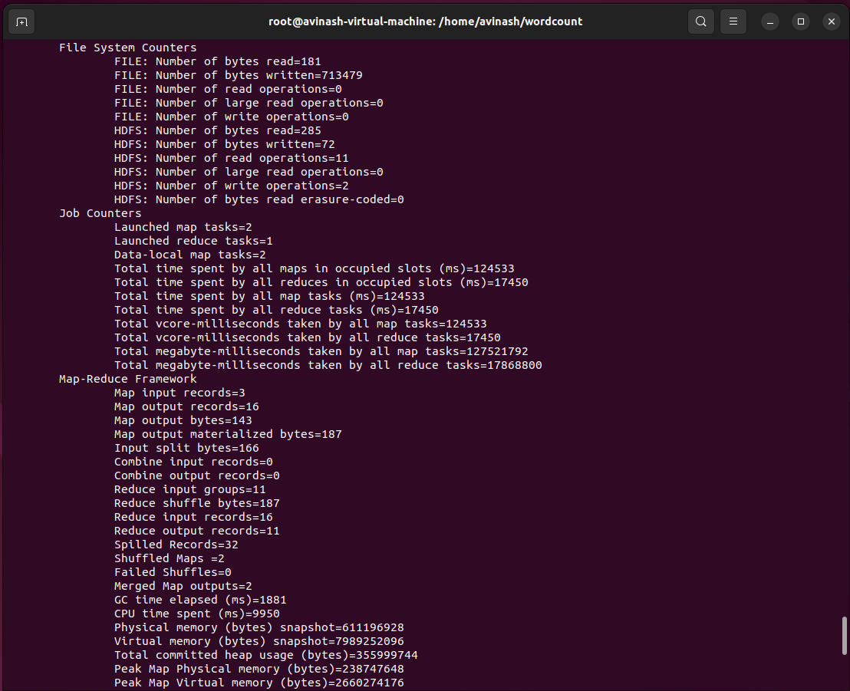

* + The output is stored in /output/part-00000
  + Now execute the command to see the output.
  + List files with permissions and other details

# hdfs dfs -ls /

# hdfs dfs -ls /output

**cat command** is used to read a file; sudo is used for super user privileges. So sudo cat means read the file with super user (that is, root) privileges.

# hdfs dfs -cat /output/part-00000

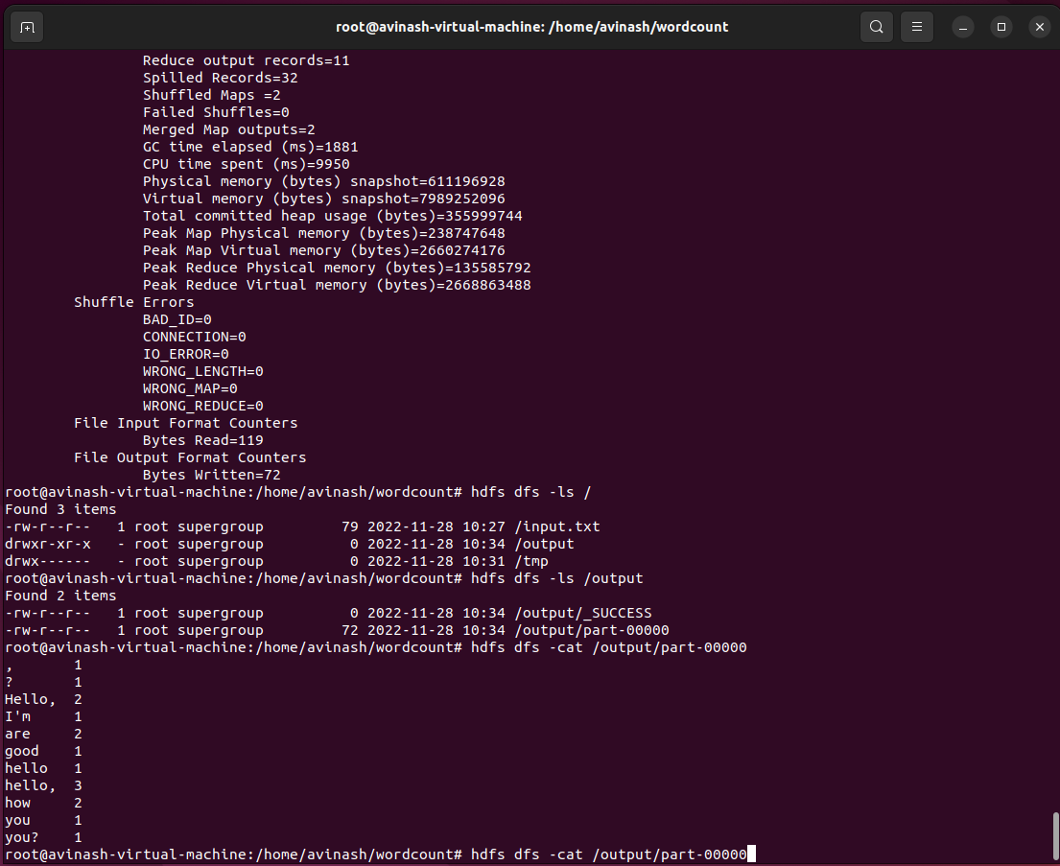

# Practical No.3

## Download and install Spark. Create Graphical data and access the graphical data using Spark.

Apache Spark is a lightning-fast unified analytics engine used for cluster computing for large data sets like BigData and Hadoop with the aim to run programs parallel across multiple nodes. It is a combination of multiple stack libraries such as SQL and Dataframes, GraphX, MLlib, and Spark Streaming.

[**https://www.apache.org/dyn/closer.lua/spark/spark-3.3.1/spark-3.3.1-bin-hadoop3.tgz**](https://www.apache.org/dyn/closer.lua/spark/spark-3.3.1/spark-3.3.1-bin-hadoop3.tgz)

**Step 1 : Update system packages.**

**The sudo apt-get update command** is used to download package information from all configured sources.

$ sudo apt-get update

### Step 2 : Install Java.

$ sudo apt install default-jdk -y

### Step 3 : Verify Java installation.

$ java -version

### Step4 : Download Apache Spark and Extract the Spark tarball.

$ sudo tar -xzvf spark-3.2.0-bin-hadoop3.2.tgz

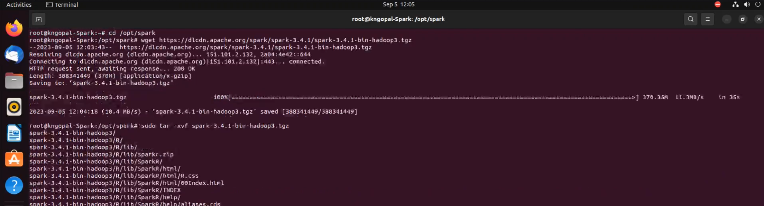

### Step 5 : Create an installation directory /opt/spark.

$ sudo mkdir / home/hadoopuser/spark/

$ sudo mv spark-3.2.0-bin-hadoop3.2/* /home/hadoop

The **.bashrc file** is a script file that’s executed when a user logs in. The file itself contains a series of configurations for the terminal session. This includes setting up or enabling: coloring, completion, shell history, command aliases, and more.

$ sudo nano ~/.bashrc



### Add the code below at the end of the file, save and exit the file:

export SPARK_HOME=/home/hadoopuser/spark/ spark-3.2.0-bin-hadoop3.2 export PATH=$PATH:$SPARK_HOME/bin:$SPARK_HOME/sbin

### Save the changes to take effectSave the changes to take effect.

### $ source ~/.bashrc

### Start the standalone master server.

### $ start-master.sh

### Find your server hostname from the dashboard by visiting

### http://Localhost:8080. Under the URL value.

### It might look like this: Spark://Ubuntu.myguest.virtualbox.org:7077

### Start the Apache Spark worker process. Change spark://ubuntu:7077 with your server hostname.

### $ start-worker.sh Spark://Ubuntu.myguest.virtualbox.org:7077

### Type spark-shell to access the shell

If spark is installed successfully then you will find the following output.

### 

import org.apache.spark.graphx._

case class User(name: String, age: Int)

val users = List((1L, User("Alex", 26)), (2L, User("Bill", 42)), (3L, User("Carol", 18)), (4L, User("Dave", 16)),(5L, User("Eve", 45)), (6L, User("Farell", 30)), (7L, User ("Garry", 32)), (8L,

User("Harry", 36)), (9L,User("Ivan", 28)), (10L, User("Jill", 48))

val usersRDD = sc.parallelize (users)

val follows = List(Edge(1L, 2L, 1), Edge(2L, 3L, 1), Edge(3L, 1L, 1), Edge(3L, 4L, 1), Edge(3L, 5L, 1), Edge(4L, 5L, 1), Edge(6L, 5L, 1), Edge(7L, 6L, 1), Edge(6L, 8L, 1), Edge(7L, 8L, 1), Edge(7L, 9L, 1), Edge(9L, 8L, 1), Edge(8L, 10L, 1), Edge(10L, 9L, 1), Edge(1L, 1L, 1))

val followsRDD = sc.parallelize(follows)

**# creating user to access data 19**

val defaultUser = User("Icarus", 22)

val socialgraph = Graph (usersRDD, followsRDD, defaultUser)

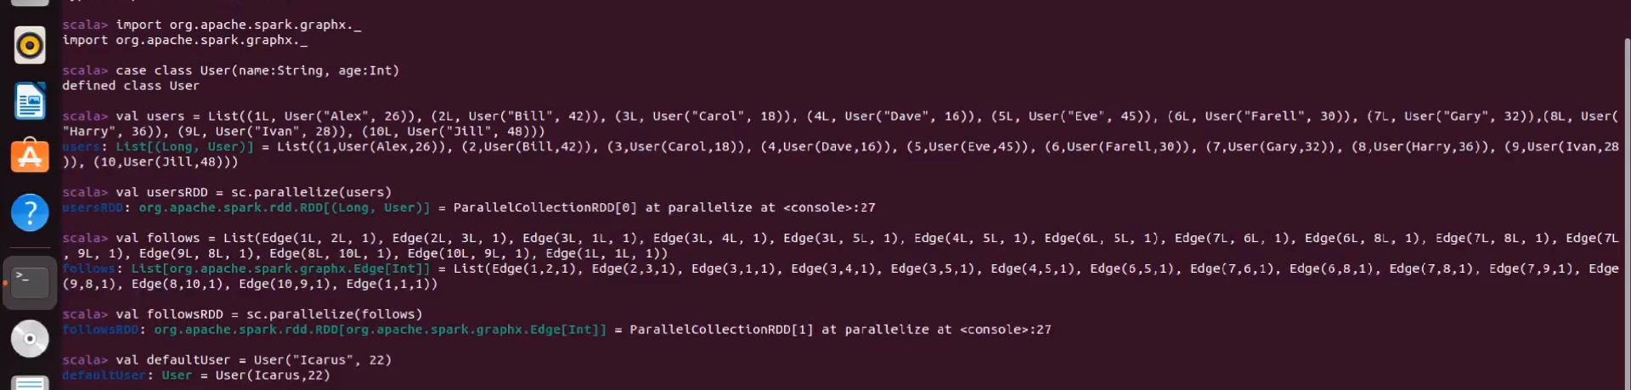

**#Access data of the graph**

socialgraph.numEdges

socialgraph.numVertices

socialgraph.inDegrees.collect

socialgraph.outDegrees.collect

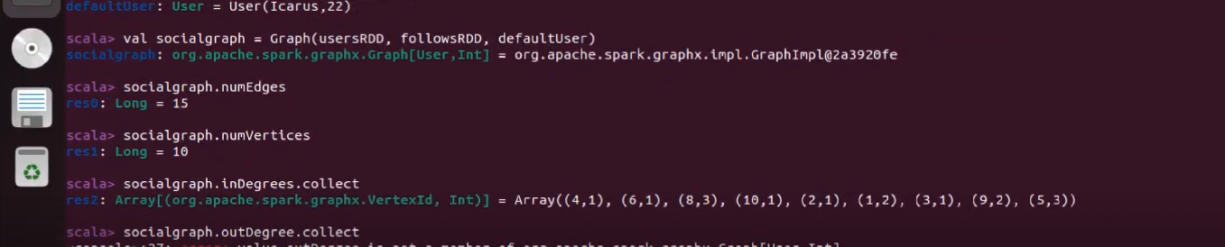

# Practical No.4

## Write a Spark code for the given application and handle error and recovery of data.

**Theory :** Scala offers different classes for functional error handling in Spark. These classes include but are not limited to Try/Success/Failure, Option/Some/None, Either/Left/Right. Depending on what you are trying to achieve you may want to choose a trio class based on the unique expected outcome of your codeScala offers different classes for functional error handling in Spark. These classes include but are not limited to Try/Success/Failure, Option/Some/None, Either/Left/Right. Depending on what you are trying to achieve you may want to choose a trio class based on the unique expected outcome of your code.

Implementation:

Install Spark to run this Practical

**# Install scala-sbt via the latest command available in the terminal**

echo "deb https://repo.scala-sbt.org/scalasbt/debian all main" | sudo tee /etc/apt/sources.list.d/sbt.list

echo "deb https://repo.scala-sbt.org/scalasbt/debian /" | sudo tee /etc/apt/sources.list.d/sbt_old.list

curl -sL"https://keyserver.ubuntu.com/pks/lookup?op=get&search=0x2EE0EA64E40A89B84B2DF73499E82A75642AC823" | sudo apt-key add

sudo apt-get update

sudo apt-get install sbt

**# enter sbt in the terminal to verify installation**

**# create the scala program for exception handling**

$ nano ExceptionHandlingTest.scala

import org.apache.spark.sql.SparkSession

object ExceptionHandlingTest {

def main(args: Array[String]): Unit = {

val spark = SparkSession

.builder

.appName("ExceptionHandlingTest")

.getOrCreate()

try {

spark.sparkContext.parallelize(0 until spark.sparkContext.defaultParallelism).foreach { i =>

if (math.random > 0.75) {

throw new Exception("Testing exception handling")

}

}

} catch {

case e: Exception =>

println(s"Exception caught: ${e.getMessage}")

} finally {

spark.stop()

}

}

}

**# create the sbt dependency file ‘exceptionhandlingtest.sbt’**

name := "exceptionhandlingtest" version := "1.0"

scalaVersion := "2.12.15" val sparkVersion = "3.3.1" libraryDependencies ++= Seq(

"org.apache.spark" %% "spark-core" % sparkVersion, "org.apache.spark" %% "spark-sql" % sparkVersion

)

**# start spark master & worker**

$ spark-master.sh

$ spark-worker.sh spark://Ubuntu.myguest.virtualbox.org:7077/

**# go back to the terminal pointing to the directory with scala and sbt file and create the sbt package**

$ sbt package

**# submit the program to spark**

$ spark-submit –class ‘ExceptionHandlingTest’ –master

‘spark://Ubuntu.myguest.virtualbox.org:7077/’ \target/scala- 2.12/exceptionhandling- 2.12-1.0.jar

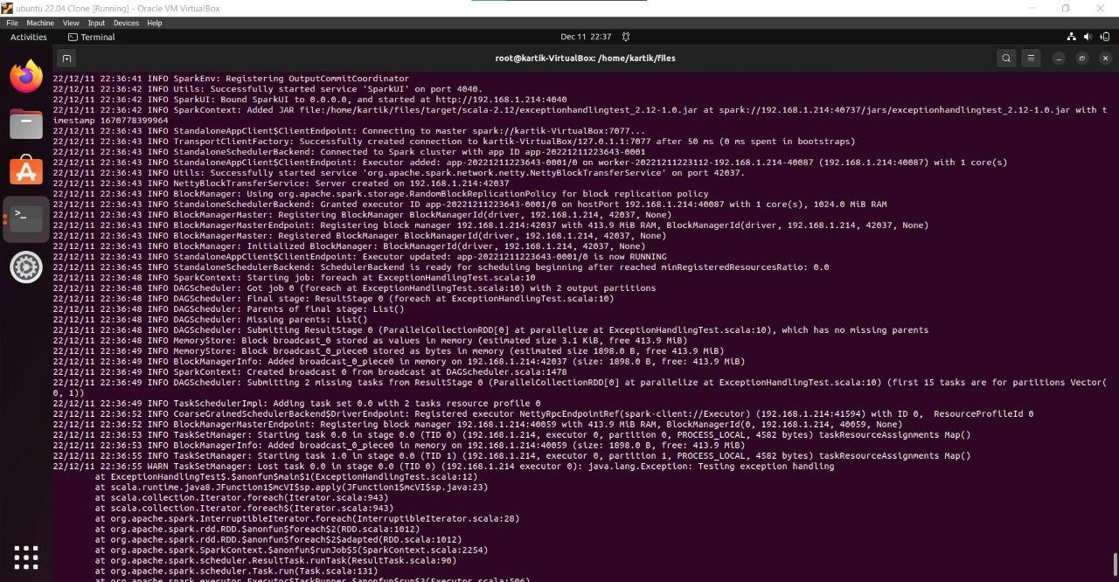

# Practical No.5

## Write a Spark code to Handle the Streaming of data.

## Theory : Spark streaming uses Spark Core's fast scheduling capability to perform streaming analytics. It ingests data in mini-batches and performs RDD transformations on those mini-batches of data. This design enables the same set of application code written for batch analytics to be used in streaming analytics, thus facilitating easy implementation of lambda architecture.

Spark streaming uses Spark Core's fast scheduling capability to perform streaming analytics. It ingests data in mini-batches and performs RDD transformations on those mini-batches of data. This design enables the same set of application code written for batch analytics to be used in streaming analytics, thus facilitating easy implementation of lambda architecture.

Implementation :

Install Spark to run this Practical

# sbt package creation

1. Create a new folder logged in as Hadoop user

2. Create file ‘NetworkWordCount.scala’ in that folder

import org.apache.spark.SparkConf

import org.apache.spark.streaming._

object NetworkWordCount {

def main(args: Array[String]): Unit = {

val sparkConf = new

SparkConf().setMaster("local[2]")setAppName("NetworkWordCount")

val ssc = new StreamingContext(sparkConf, Seconds(10))

val lines = ssc.socketTextStream("localhost",9999)

val words = lines.flatMap(_.split(" "))

val tuples = words.map(word => (word ,1))

val wordCounts = tuples.reduceByKey((t, v) => t + v)

wordCounts.print()

ssc.start()

ssc.awaitTermination()

}

}

3. Create a ‘networkwordcount.sbt’ file in the same folder

name := "networkwordcount"

version := "1.0.0"

scalaVersion := "2.12.15"

libraryDependencies += "org.apache.spark" % "spark-streaming_2.12" % "3.3.1" %

"provided"

4. Create the sbt package

$ sbt package

5. Start the spark server

$ start-master.sh

$ start-worker.sh spark://Ubuntu.myguest.virtualbox.org:7077/

6. On a separate terminal, start the netscape server

$ nc –lk 9999

7. On the original terminal, submit the scala program to spark

$ spark-submit –class ‘NetworkWordCount –master

‘spark://Ubuntu.myguest.virtualbox.org:7077/’ \target/scala2.12/networkwordcount_2.12-1.0.0.jar

8. On the netscape terminal provide textual input for the scala program to count words of the live

stream every 10 seconds

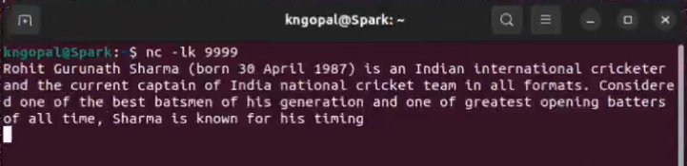

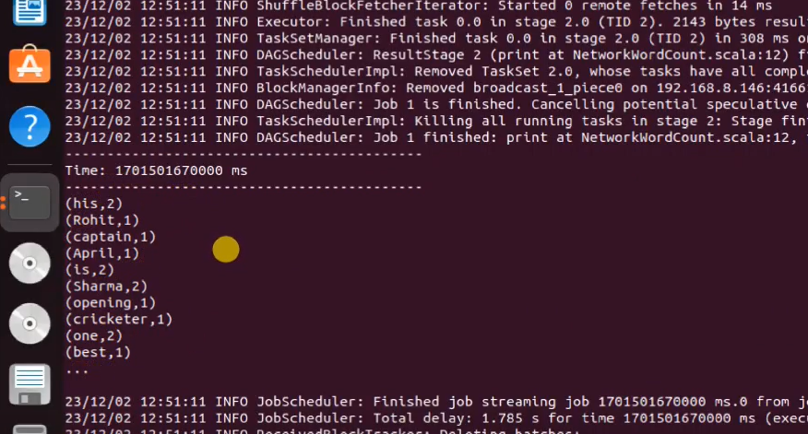

# Practical No.6

## Install Hive and use Hive Create and store structured databases.

Apache Hive is a distributed, fault-tolerant data warehouse system that enables analytics at a massive scale. A data warehouse provides a central store of information that can easily be analysed to make informed, data driven decisions. Hive allows users to read, write, and manage petabytes of data using SQL.

**Use the given link to Login** : https://demo.gethue.com/ The credentials to Login are –

Username : demo Password : demo



You'll get a screen as attached below once you successfully Login

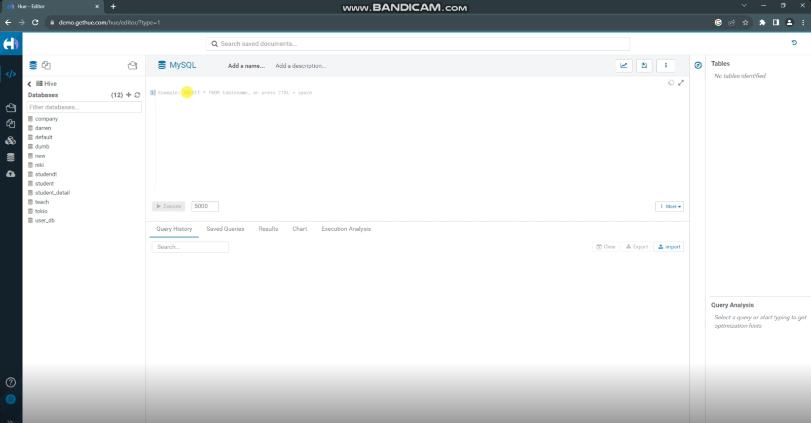

Navigate to the Menu bar located to the left side of the screen and hover over the Editor Menu > Select your editor as Hive. (Note : Make sure to always select Hive whenever you get such options

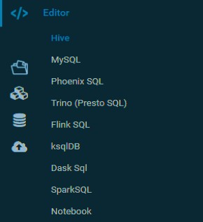

### Step 1: Create a Database

1. **Create a database named** “[any database name you want]” by running the create **command: create database name;**

Create Database, Hive is a database technology that can define databases and tables to analyze structured data.

### Next, verify the database is created by running the show command:

show databases;

* + Your database name will be listed in the “Results” section as attached in the below snapshot.
  + [Note : It takes some time for your database to be visible ; If you still can't see your database it will be visible once you use your database].

1. Find the “[created database]” database in the list:

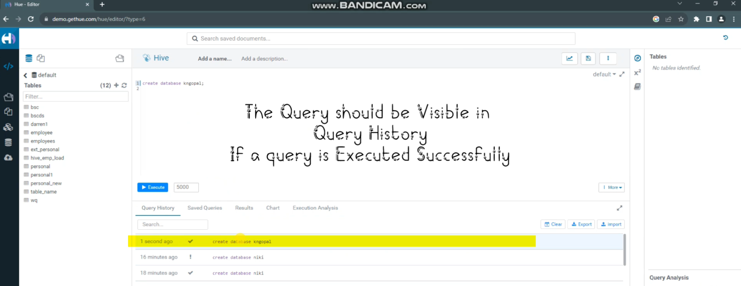

1. Open the “kngopal” database by using the following command:

This hive command is used to select a specific database for the session on which hive queries would be executed.

use kngopal;

Or manually select ‘kngopal’ as shown below:

[Note : Make sure the database name is changed from ‘default’ to ‘the database name you have created’]

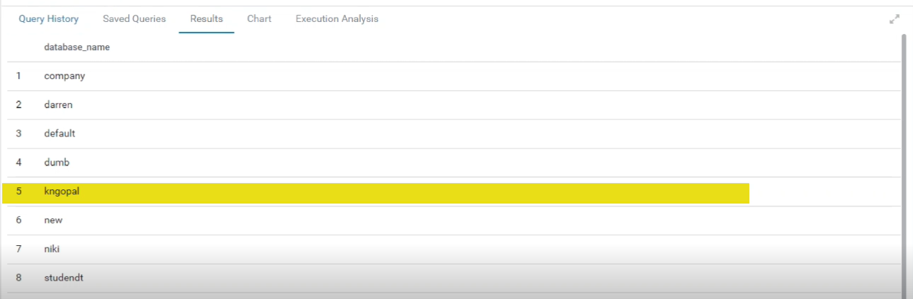

### Step 2: Create a Table in Hive

1. **Create the table by running the following command: (can use any names and data types) Create Database** is a statement used to create a database in Hive.

create table students (id int, name string, country string, department string)

* + You can see your created table by selecting the ‘Tables’ menu from the left hand side. In the dropdown Select ‘Hive’ instead of ‘MySql’

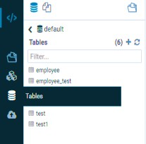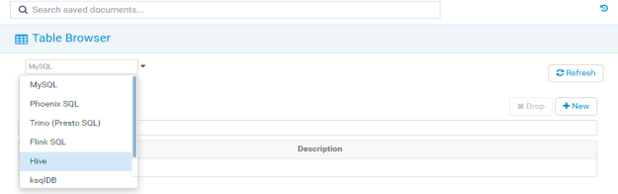

### Step 3: Inserting values into the created Table

Your values will be inserted once you execute the given command.

**SELECT statement** is used to retrieve the data from a table. WHERE clause works similar to a condition. It filters the data using the condition and gives you a finite result.

select * from students;

The **INSERT** ... **VALUES statement** is revised to support adding multiple values into table columns directly from SQL statements. A valid INSERT ... VALUES statement must provide values for each column in the table.

insert into students values (11,’Gopal’,’India’,’CS’);

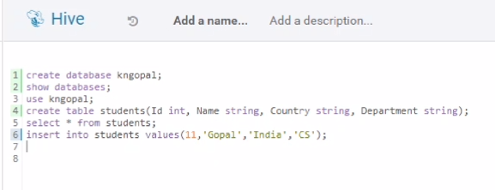

### Step 4: Displaying the inserted data.

You can view the data by using the given commands.

* **SELECT statement** is used to retrieve the data from a table. WHERE clause works similar to a condition. It filters the data using the condition and gives you a finite result.

select * from employees;

* **DESCRIBE|DESC DATABASE** shows the name of the database, its comment (if one has been set), and its root location on the filesystem.

DESCRIBE employees;

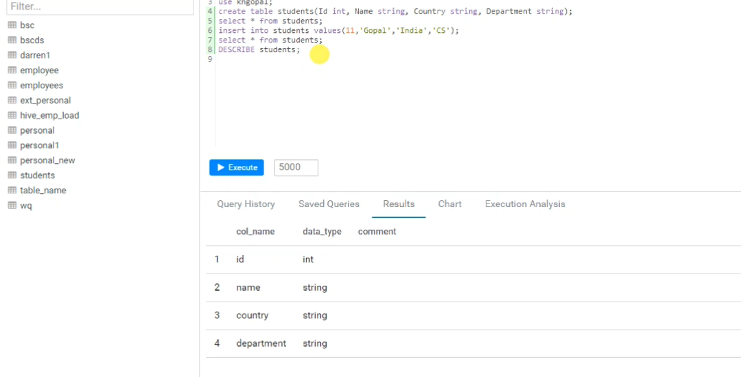

**SELECT statement** is used to retrieve the data from a table. WHERE clause works similar to a condition. It filters the data using the condition and gives you a finite result.

select * from students;

select name,country,department from studensts;

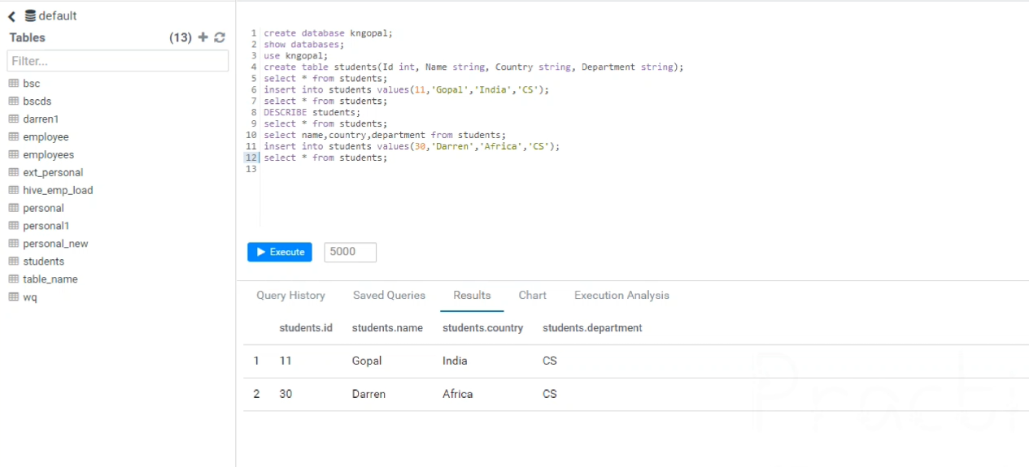

# Practical No.7

## Aim : Install HBase and use the HBase Data model Store and retrieve data.

Theory: HBase is an open-source non-relational distributed database modeled after Google's Bigtable and written in Java. It is developed as part of Apache Software Foundation's Apache Hadoop project and runs on top of HDFS (Hadoop Distributed File System) or Alluxio, providing Bigtable-like capabilities for Hadoop. That is, it provides a fault-tolerant way of storing large quantities of sparse data (small amounts of information caught within a large collection of empty or unimportant data, such as finding the 50 largest items in a group of 2 billion records, or finding the non-zero items representing less than 0.1% of a huge collection).

Apache HBase is an open-source, NoSQL, distributed big data store. It enables random, strictly consistent, real-time access to petabytes of data. HBase is very effective for handling large, sparse datasets. Data Model in HBase is designed to accommodate semi-structured data that could vary in field size, data type and columns.

# Implementation:

# Install Hadoop to run this Practical

# #HBase installation

# 1. Go to the official site and download the most stable version of hbase

# 2. Extract the zip file and place it in Hadoop home directory

# 3. Open hbase-env.sh in hbase/conf and assign the JAVA_HOME path

# $ sudo nano hbase/conf/hbase-env.sh

# export JAVA_HOME=/usr/lib/jvm/java-11-openjdk-amd64

# 4. Edit the .bashrc file

# $ nano ~/.basrhc

# export HBASE_HOME=/home/hbuser/hbase

# export PATH= $PATH:$HBASE_HOME/bin

# 5. Read the edited bashrc file to the running memory

# $ source ~/.bashrc

# 6. Add the following properties below the existing ones in the hbase/conf/hbase-site.xml file

# <property>

# <name>hbase.rootdir</name>

# <value>file:///home/hbuser/hbase</value>

# </property>

# <property>

# <name>hbase.zookeeper.property.dataDir</name>

# <value>/home/hbuser/hbase</value>

# </property>

# 7. Run hbase by typing

# $ start-hbase.sh

# $ hbase shell

# # Storing and retrieval of data

# # Enter the following command in the hbase shell

# > create ‘students’, ‘details’

# > list ‘students’

# > put ‘student’, 1, ‘details:name’, ‘Rohit’

# > put ‘student’, 1, ‘details:roll no’, ‘01’

# > put ‘student’, 2, ‘details:name’, ‘Gopal’

# > put ‘student’, 2, ‘details:roll no’, ‘11’

# > scan ‘student’

# 

# Practical No.8

## Write a Pig Script for solving counting problems.

Theory: Apache Pig is a high-level platform for creating programs that run on Apache Hadoop. The language for this platform is called Pig Latin. Pig can execute its Hadoop jobs in MapReduce, Apache Tez, or Apache Spark. Pig Latin abstracts the programming from the Java MapReduce idiom into a notation which makes MapReduce programming high level, similar to that of SQL for relational database management systems.

Apache Pig is an abstraction over MapReduce. It is a tool/platform which is used to analyse larger sets of data representing them as data flows. Pig is generally used with Hadoop; we can perform all the data manipulation operations in Hadoop using Pig.

Steps to follow :

* The first installing Apache Pig you should have Java and Hadoop installed.
* Pig is a scripting platform that is designed to process and analyze large datasets which were developed in late 2006 by Yahoo researchers.
* Run Hadoop on ubuntu (I have installed Hadoop 3.2.1 on Ubuntu 16.04).
* Go to <https://pig.apache.org/releases.html>and copy the path of the latest version of pig that you want to install.

# Pig installation

1.Download the zip file from the official Pig release site

2.Extract the pig zip

$ sudo tar –xf pig-0-17.0.tar.gx

3.Moving the file

$ mv pig-0-17-0 /home/Hadoop/pig

4.Set the .bashrc file

export PIG_HOME=/home/hadoop/pig

export PATH =$PATH:/home/hadoop/pig/bin

export PIG_CLASSPATH=$HADOOP_HOME/conf

5.Verify installation

$ pig –version

6.Run pig locally

$ pig –x local

# Pig script for word count problem

Create a text file in /home/Hadoop/textfile.txt path and provide content

$ nano /home/hadoop/textfile.txt

Enter the following command in the terminal

lines = LOAD ‘/home/hadoop/textfile.txt’ AS (line:chararray);

words = FOREACH lines GENERATE FLATTEN(TOKENIZE(line)) as word;

grouped = GROUP words BY word;

wordcount = FOREACH grouped GENERATE group, COUNT(words);

DUMP wordcount;

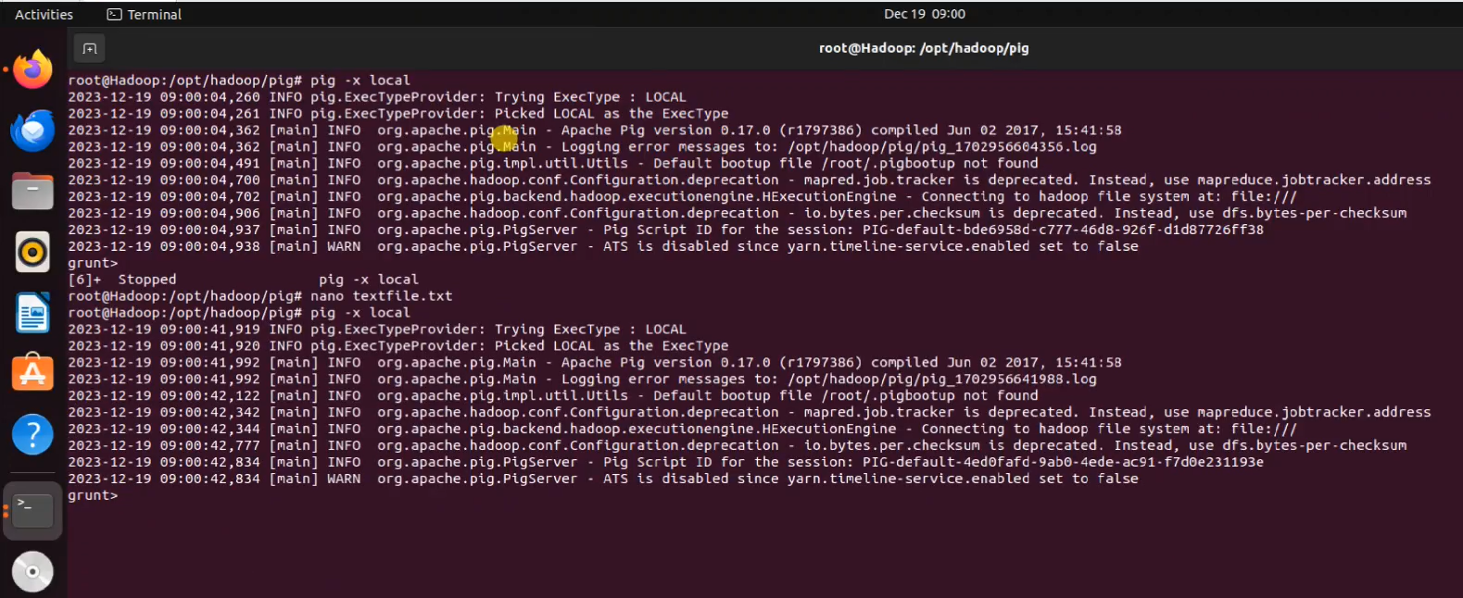

OUTPUT :

